**Mobile Application Development Course Project**

Global Networking App

(Project Report)



Dua Fatima – 231521040

Faizan Ahmed – 241608482

Date of Submission: 29th May, 2024.

Table of Contents

Introduction 3

Objectives 5

Problem Statement 8

Literature Review 9

Comparative Analysis 13

Design 15

References 22

# Introduction

In the digital age, cross-border interactions and partnerships are important because they have played a vital role in improving the systems in the organizations to a great extent. Traditional networking techniques are constrained by both physical and technical hurdles in an organization, making it challenging to reach foreign markets as well as in having a broad talent pool. Digital technology may resolve all of these issues by enabling effortless, interactive global networking (Schiller, 1999). A complete global networking application that can cross geographical and cultural boundaries has been suggested in this project. The software offers a smooth interaction platform for professionals, entrepreneurs, and enterprises wishing to develop globally basically and this is app is a mixture of widely used apps, for example it shares an interface of zoom, upwork, and slack, since it was noticed how difficult it was for clients to have one option but not the other. The software uses innovative technology to deliver a user-friendly, multifunctional platform for worldwide networking, real-time communication, content sharing, and personal branding. The global networking app tackles multiple major concerns facing individuals and companies in an increasingly globalized world. First, it opens foreign markets for product and company development. Traditional networking methods can be constrained by geography, making global company outreach challenging. This program removes such obstacles through the integration of multimedia features to help businesses reach foreign customers.

Second, the app solves around the world networking and career advising challenges. Today's competitive industry requires an extensive and diverse network of specialists and mentors for career progress, so that they are on an edge in being a competitive partner in the business field. Users may network with people from various areas, obtain professional advice, and establish new connections with the app. The software handles professional language and cultural issues. It comes with numerous languages and cultural exchange capabilities so users can communicate and do business anywhere. Global interaction can occur in a more inclusive and productive environment. This app's main focus and target audience is professionals seeking possibilities and opportunities in an international market, organizations expanding globally, and individuals seeking networking and career assistance. Its simple interface suits the needs of diverse users.

The global networking app guarantees to revolutionize how people and companies connect in the digital age by addressing access to foreign markets, global networking possibilities, and linguistic and cultural obstacles, not only this by looking that how mandatory it is for small or startup business to connect with bigger fishes in the business in order to grow their worth, which is why such platforms play a key role (Ronchi, 2009). The app's many features foster a lively, integrated worldwide community. Advanced technical linkages allow real-time communication in the application's interface. Instant messaging, video conferencing, and group chat are included. The program allows real-time interactions to let users cooperate throughout time zones. Professionals that need to make quick choices, have corporate conferences, or teach need quick interaction.

Audio and video broadcasting allow users to sell their products and services in new ways. Webinars, live product demos, plus global broadcasting boost visibility for brands (Juska, 2021).

AR and VR increase the user experience by creating immersive and engaging product displays. This innovation differentiates the app from other social media platforms and gives customers a unique value proposition, because many people like to see and hear the client or the person applying, this also plays a role in building trust through a platform. Digital personal branding is emphasized in the software, and how it can enhance the customer experience. It helps users customize their profiles to highlight their skills and achievements. This helps people stand out in a crowded global market and renders relationships with similar professionals and enterprises more meaningful. The simple profile management system helps users update their information and highlight their professional achievements, which can further help how they can attract clients and companies globally.

Content sharing and interaction are important app features. Share text, photos, videos, and links and relate with likes, comments, and shares. This fosters an engaged community where ideas and skills may be exchanged, building the market and introducing talent without the hurdle in global barriers. The software encourages collaboration and best practices, fostering learning and growth. The app's notifications keep users informed and engaged. The program warns users about significant messages, connection requests, and updates in real time so they can respond quickly. This feature benefits professionals who must be connected and responsive in a fast-paced international setting. Digital users value data privacy and security. Strong data and privacy security mechanisms address these vulnerabilities in the app. Included are secure authentication, data encryption, and multinational data protection. Users feel safe using the app since it promotes security and privacy.

The app is more comprehensive with multilingual support, since this is a platform for clients all around the world so that is why it has this support. Multilingual network utilization demands software that supports several languages. This is essential for a global networking platform with users of various backgrounds and cultures. Languages enable swapping and customizing easier in the app. App innovation utilizes machine learning. Machine learning algorithms change app suggestions to user preferences and movement. Personalization increases user engagement and satisfaction, making the app more useful and interesting, and for it to be referred to more people in the market. Finally, the global networking app answers the major globalization challenges for people as well as companies. The software links people worldwide through real-time discussion, sharing, personal branding, and data protection. The software's accessibility, participation, and flexibility fulfill user needs, creating a more creative and interdependent global environment. The initiative uses technologies to bridge regional and cultural disparities for global interaction and collaboration.

# Objectives

This project aims to create a cutting-edge global networking tool that bridges borders and promotes worldwide collaboration. The software provides a powerful, user-friendly platform for real-time conversation, content sharing, and personal branding, making networking fun and productive globally. Creating smooth international connectivity is a priority. The app helps users identify, connect, and interact with global professionals and organizations. The program removes geographical borders, allowing users to expand their networks and access previously unavailable services.

Real-time communication must also be improved. The software allows real-time collaboration using instant messaging, video calling, and group conversations. . Multiple languages make the software more accessible and reduce communication hurdles. This helps multilingual users interact with the site. The app's language settings make switching languages and customizing the experience easy.

Finally, the app uses machine learning to tailor user experience. Machine learning algorithms let the app customize features and suggestions to user preferences and behavior. Personalization boosts user engagement and pleasure, making the app more helpful and relevant. The app's machine learning features provide personalized content, networking, and notification suggestions to provide users a richer experience. The worldwide networking software is flexible and entertaining to fulfill users' different demands. The software promotes worldwide collaboration by using innovative technology and user-centric features. Real-time communication, content sharing, personal branding, data protection, and customisation make the app a smooth and effective networking tool. The app's creative strategy overcomes geographical and cultural gaps, providing a dynamic and linked global environment that empowers users to accomplish personal and professional goals. This project aims to create a cutting-edge global networking tool that bridges borders and promotes worldwide collaboration. The software provides a powerful, user-friendly platform for real-time conversation, content sharing, and personal branding, making networking fun and productive globally.

Creating smooth international connectivity is a priority. The app helps users identify, connect, and interact with global professionals and organizations. The program removes geographical borders, allowing users to expand their networks and access previously unavailable services. Real-time communication must also be improved. The software allows real-time collaboration using instant messaging, video calling, and group conversations. Communication must be immediate to promote cooperation and enable users to respond quickly to opportunities and difficulties (Nardi, et al., 2000). Real-time communication supports virtual meetings and webinars, which are essential for organizations and professionals communicating with overseas partners and clients.

The software promotes content exchange and engagement. Share text, photographs, videos, and links and interact with others through likes, comments, and shares. This feature offers a thriving community where people can share ideas, exhibit their work, and collaborate and learn. The software lets users create their own brands, acquire notoriety, and become thought leaders by sharing information. Supporting complete profile management is another goal. Users may create and manage extensive profiles that emphasize their abilities, experiences, and successes using the app. It boosts personal branding and exposure, helping individuals stand out in a competitive worldwide market. The profile management system is easy to use, so users may update their information and exhibit their career. Users' profiles will feature professional background, talents, endorsements, and portfolio items to show their whole professional identity.

Customizable alerts and updates are also important. The software sends real-time notifications about critical events, messages, and changes. This keeps consumers informed and engaged with the software. The notification system is versatile, letting users tailor their notifications. Users may get notifications for new connection requests, messages, and content updates to stay connected and responsive without being overwhelmed. Data privacy and security are the app's main priorities. The software meets international data protection requirements with strong security features to secure user data and privacy. Multiple languages make the software more accessible and reduce communication hurdles. This helps multilingual users interact with the site. The app's language settings make switching languages and customizing the experience easy. Multilingual functionality offers message and post translation, allowing users to communicate in any language.

Finally, the app uses machine learning to tailor user experience. Machine learning algorithms let the app customize features and suggestions to user preferences and behavior. Personalization boosts user engagement and pleasure, making the app more helpful and relevant. The app's machine learning features provide personalized content, networking, and notification suggestions to provide users a richer experience.The program also matches users with seasoned experts who may guide them in their careers. Additionally, the app aims to foster community and belonging. The app brings like-minded people together to share experiences and work on projects through virtual events, debates, and interest-based groups. Community is crucial for genuine interactions and long-term professional ties (Sampson, 1988). The worldwide networking software is flexible and entertaining to fulfill users' different demands. The software promotes worldwide collaboration by using innovative technology and user-centric features. The app's real-time communication, content sharing, personal branding, data protection, customization, and professional growth make networking easy and efficient. The app's creative strategy overcomes geographical and cultural gaps, providing a dynamic and linked global environment that empowers users to accomplish personal and professional goals.

# Problem Statement

In an increasingly connected world, professionals and organizations struggle for the benefit of global networking. Traditional networking methods like in-person meetings, meetings, and regional events are constrained by geographical location, administrative tasks, and attitude. These barriers impede global trade, finding talent, and career and business prospects as well as business opportunities. Limited foreign market access for product demonstration and business growth is a major challenge. Many SMEs and major organizations struggle to contact consumers and partners outside their immediate geographic zone. Without an effective worldwide platform to showcase products and services, their growth and market reach are limited. Finding professional guidance and worldwide networking possibilities is another major issue. In today's competitive employment market, a diversified network of experts and mentors is essential for career growth. Traditional networking strategies are sometimes limited by geography, making it difficult to interact with business leaders, mentors, and peers from around the world.

Language and cultural barriers hinder communication and collaboration for many individuals and enterprises. Poor linguistic and cultural awareness may result in miscommunications, misunderstandings, and missed chances to succeed. Professional collaboration and debates require precise communication, which is difficult. Digital solutions to such problems typically fail at many levels. Some networking apps are either overly broad, missing international networking capability, or overly restrictive, lacking professional involvement options (Bughin et al., 2018). Global networking involves immediate interaction, multimedia, and multi-language capability, which these networks lack. Data security and privacy concerns are escalating. Due to data breaches and illegal access, professionals and organizations are leery about publishing critical information online. Lack of strong security and transparent privacy rules on existing platforms reduces user confidence and engagement. Many networking sites lack individualized user experiences, which lowers engagement and happiness. Users typically struggle to identify appropriate connections, material, and opportunities for their hobbies and career aspirations. Lack of customisation inhibits networking users from realizing advantages.

Thus, a complete global networking program that tackles these issues is needed. An app should provide real-time collaboration, multi-language interactions, global market access, and data privacy, because this is seen as a problem and clients find it not very useful in terms of the growth of their businesses. For professionals and businesses expanding abroad, it should offer personalized user experiences. Addressing these challenges in the software may let users network globally, progress professionally, and achieve economic objectives in a digital and developed relationships environment.

# Literature Review

Recent digital apps promise to enhance worldwide networking, career advancement, and professional cooperation. This literature study analyzes networking apps' functionality, design, user interfaces, and other key characteristics. We may assess these applications' strengths and limitations, market gaps, and how our suggested global networking app might improve user experience by reviewing them. LinkedIn has over 700 million members and is the largest professional networking site. Professionals may build profiles, interact with colleagues, follow businesses, and join industry groups. The main LinkedIn features are, users may establish detailed profiles with employment experience, education, talents, and colleague recommendations. Professionals network online through invitations and connections. Messaging, group chats, and content participation are possible. LinkedIn users may post updates, articles, and videos. Likes, comments, and shares create a vibrant community. LinkedIn's job board enables users browse, apply, and receive profile-based suggestions. LinkedIn Learning offers several courses. LinkedIn has limitations despite popularity. New users may find the platform's UI overwhelming due to its many features. LinkedIn supports other languages, however its English-centric content may confuse non-English users. The platform sends messages asynchronously. Professional networking site Xing is popular in German-speaking countries. It gives localized markets LinkedIn-like functionality. Main features, Users can list career interests. Xing links connections and groups. Users can network and share ideas in industry groups. The site displays jobs and makes profile-based suggestions. Xing enables people to register for professional events online and offline. Post updates, articles, and join discussions. The user-friendly design and geographical focus of Xing make it useful for German-speaking users. Compared to LinkedIn, its worldwide reach is restricted. Real-time communication and multimedia services are lacking on Xing. Shapr allows professional networking with a social-media interface. It makes networking easier and more fun. Key features, shapr matches people by hobbies and career aspirations using a Tinder-like swipe function. Users can emphasize their professional backgrounds, interests, and networking ambitions. The app offers a handpicked list of possible matches daily to encourage networking. Shapr lets users message matches in-app. The Shapr matching mechanism makes networking more fun and informal. Its simplicity might be a drawback, as it lacks the functionalities of LinkedIn. Users seeking professional relationships may not like the app's informal networking orientation. Meetup organizes in-person and virtual gatherings around similar interests. While not entirely for business networking, it offers important professional growth and relationships. Key features:

Users can invite people with similar interests to events. Users can join industry-specific or topic-specific groups to network and collaborate. Based on interests and preferences, the platform helps users find local or online events. Event organizers can exchange information, updates, and announcements with group members. Event-focused Meetup is a unique networking platform. It lacks LinkedIn's elaborate profile and job search options. Focusing on interest-based groups may limit professional networking prospects.

The dating app Bumble has a professional networking section called Bumble Bizz. Bumble Bizz helps professionals connect via Bumble's swipe-based interface. Key features, users can showcase their professional accomplishments, talents, and objectives. Like Shapr, Bumble Bizz matches people by professional interests. Users may message matches in-app, Bumble's basic premise is for women to start matches to create a more polite networking atmosphere.

Integration with the famous Bumble app makes Bumble Bizz easy to use. However, its focus on informal networking and start as a dating app may alienate professional users. Missing are job listings and professional development resources.

Professional networking site Viadeo targets French-speaking professionals. It delivers LinkedIn-like features regionally. Key features, users can add professional background, talents, and endorsements. Viadeo supports networking through shared contacts and groups.The website lists jobs and makes suggestions based on user profiles. Users may publish updates, articles, and join discussions. Companies may exhibit their brand and engage with potential hires. Through its regionally specialized platform, Viadeo excels in the French-speaking market. It lacks LinkedIn Learning and sophisticated content sharing options, and its international reach is restricted.

Alignable is a networking tool for local and small enterprises. It promotes small business communities and collaboration. Key features, users can showcase their goods, services, and history. Alignable fosters networking and referrals through common contacts and community recommendations. The website lets users find and attend local business events and networking opportunities. Alignable lets company owners express questions, exchange advice, and cooperate on local concerns. Alignable's focus on small enterprises and local communities helps local networking and company growth. However, its regional concentration may limit its usefulness for professionals seeking worldwide relationships. Advanced multimedia and real-time communication are missing.

Each professional networking tool has pros and cons. LinkedIn is extensive and worldwide, but novice users may find it intimidating and lack real-time communication facilities. Xing has a simple UI and localized focus but little worldwide penetration. Innovative swipe-based matching apps like Shapr and Bumble Bizz may not be serious enough for certain users. Event facilitation is Meetup's strength, but professional networking is lacking. Alignable is great for local business networking but not worldwide, while Viadeo is great for French-speaking professionals. Our worldwide networking app builds on these platforms' strengths and addresses their weaknesses. Our software will improve networking with smooth international connections, real-time communication, complete profile management, customized notifications, robust data security, multi-language support, and individualized user experiences. This software will link users across cultures and geographies to help them network, grow professionally, and achieve business goals in a digital environment.

Zoom is used for remote business, online education, and virtual meetings. The primary features, Zoom provides HD one-on-one and group video meetings, The software offers webinars with attendance registration, polling, and Q&A. Sharing screens simplifies real-time presentation and collaboration, Recording and transcription let attendees review the content later, Zoom allows smaller group talks within bigger meetings for more focused cooperation, Custom virtual backgrounds enhance privacy and professionalism, Video conferencing in-meeting chat allows messaging. Zoom's intuitive interface and extensive feature set make it a popular virtual conferencing tool. Zoom has fantastic real-time chat but no profile maintenance, job search, or long-term networking. Communication, not professional networking, is the platform's goal.

Professionals using Slack for project management and team communication. The primary features, users can create project, team, or topic channels to manage talks.

Direct Messaging: Slack provides real-time group and individual communication. Slack integrates with third-party tools to boost productivity and project management. Slack's advanced search lets users quickly find past messages and files. Get essential updates without getting overwhelmed with alerts. Internal team communication and cooperation are wonderful with Slack, but not external networking. The focus is on team production, not networking or job searching. However, public Slack groups for particular industries or interests may offer networking opportunities.

The major freelancing job site On Upwork, clients find freelancers with varied expertise. Main features, fFreelancer profiles might contain skills, work history, portfolio, and client reviews. Clients publish job postings that freelancers may view and apply for in many areas, Freelancers submit task proposals with their methodology, timing, and cost. Upwork's project management features track time, manage projects, and communicate with customers. The software handles payments and invoicing securely and quickly. Reviews, contractors and clients may submit reviews to develop trust. Upwork serves freelancers and project managers, the freelancer-client, project, and payment functions are extensive. Projects trump long-term relationships at Upwork.

Beyond texting, it lacks real-time communication, networking, and career growth beyond freelancing.

# Comparative Analysis

Zoom, Slack, Upwork

Zoom, Slack, and Upwork have different professional uses. Zoom excels in real-time communication, Slack at team collaboration, and Upwork at freelancer-client matching. These systems do not provide a complete global networking solution that integrates real-time communication, project management, and professional networking.

Advantages and Drawbacks

Zoom has great video conferencing, UI, screen sharing, and breakout rooms. Networking and profile management are lacking. Slack includes robust team communication, integrations, and customizable notifications. Lack of external networking and advancement in your profession is its main drawback. Upwork has robust independently management, secure payment processing, and thorough profile construction. Drawbacks include the transaction platform and limited real-time communication.

Design/UI

Zoom's basic UI makes it accessible to all skill levels. The UI is geared for video conferencing, making meeting preparation and participation easy. Slack's customisable design boosts productivity with structured channels and connectors. Users may easily handle various discussions and tasks with its straightforward design. Its interface simplifies job searching and project management. It helps freelancers and clients find jobs, make bids, and manage projects.

Zoom, Slack, and Upwork demonstrate global networking software gaps and potential. These sites provide collaboration and freelance employment, but not networking. The suggested global networking software repairs and enhances these systems.

Proposed Global Networking App

Global networking would involve project management, real-time communication, and professional networking.Upwork, Zoom, and Slack are integrated for professional networking as well as cooperation. The project will translate various languages for international audiences.

The initiative will prioritize privacy and data security in order to meet global requirements and safeguard user data. The proposed program will bridge gaps in present platforms and provide a unique and advantageous global networking solution. Professional connections, project collaboration, and career advancement are possible in a smooth, integrated environment. Zoom, Slack, and Upwork's pros and cons for professional collaboration, communication, and networking. Each platform shines in its own area, but none offer a complete global networking solution. The global networking app proposes merging the best of these platforms and resolving their drawbacks to close this gap. The app's seamless, integrated environment for real-time communication, project management, and professional networking will enable users to leverage global networking opportunities, grow professionally, and achieve business goals in a digital, interconnected world. With its revolutionary features and user-centric design, the app will redefine professional networking in the digital era.

# Design

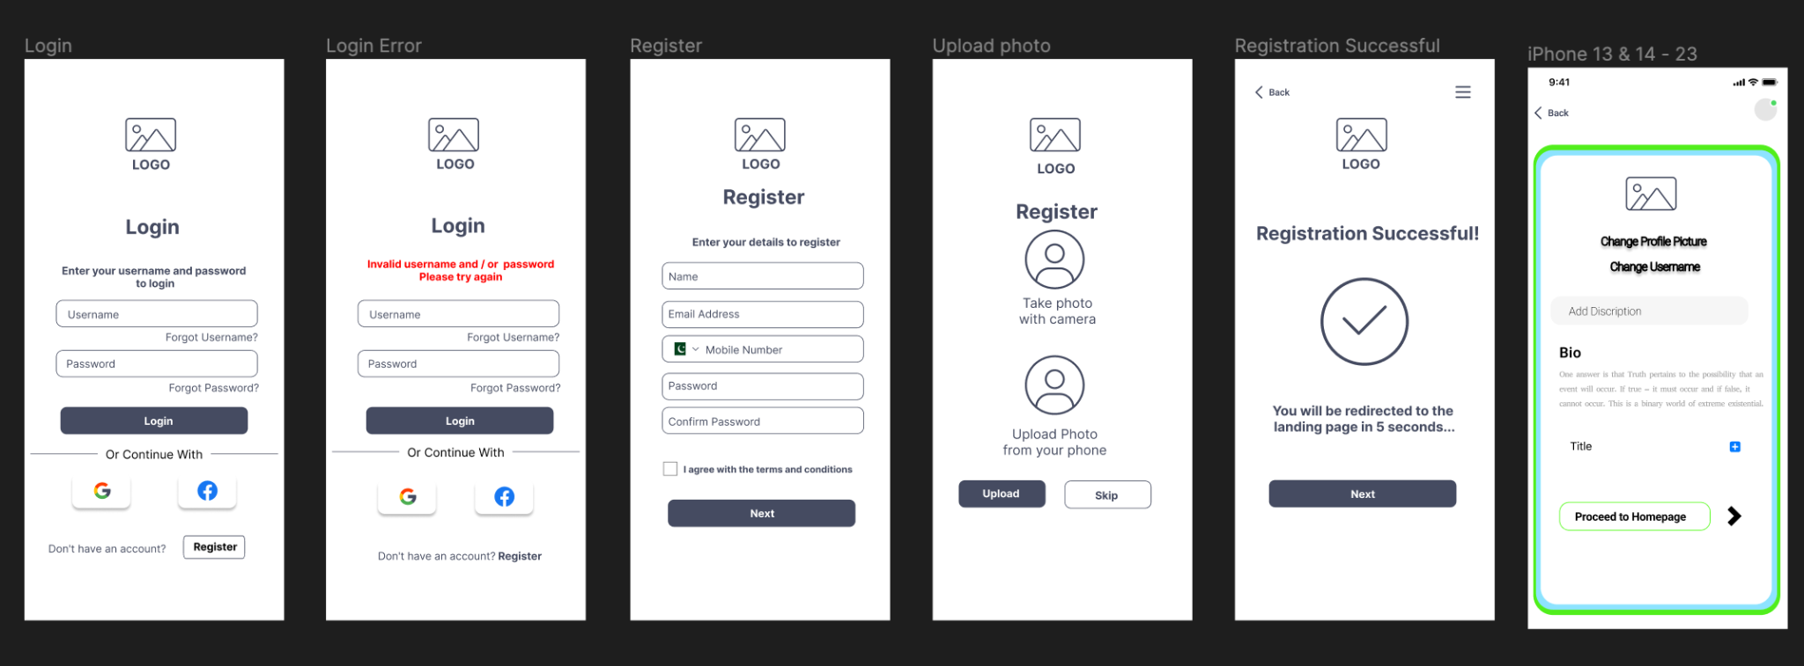

The Figma and UI design shows how users register, login, and set up profiles on the worldwide networking app. This design focuses usability and navigation for a smooth user experience.

Screens to login

Users login with their username and password on the first screen. The design is simple, with clear input fields and a big "Login" button. Links for lost usernames and passwords are easy to discover. Users who prefer social login can continue using Google or Facebook for faster access. The second screen indicates login errors. Red error messages remind users to re-enter their credentials if their credentials are wrong. This feedback helps users identify and fix errors fast.

Registration begins on the third screen, where new users input their name, email, cell phone number, and password. The simple layout guides visitors through needed information. A tickbox for terms and conditions assures legal compliance and user permission. On the fourth page, users may upload a profile photo from their smartphone or capture one with their camera. This is essential for tailoring user profiles and increasing app engagement. Registration is verified on screen five. A notice alerts the user that they will soon be taken to the landing page, the next onboarding step.

The last screen lets users change their bio, username, and profile image. The UI is simple with huge action buttons. The bio section enables people quickly define themselves, making profiles tailored and intriguing. Figma and UI prioritize simplicity and user experience, making registration and login straightforward. Designing a user-friendly global networking platform that simplifies interactions begins here.

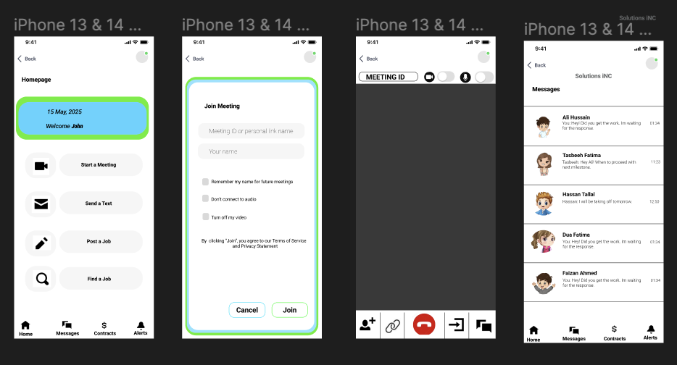

The Figma and UI design emphasizes the global networking app's homepage, meeting planning, and messaging. The software prioritizes user and professional communication with these panels. Homepage is the first screen and user hub. The current date and a unique welcome message are shown simply. Features include "Start a Meeting," "Send a Text," "Post a Job," and "Find a Job." Users can easily explore and access crucial app features with this basic design.

The bottom navigation bar makes Home, Messages, Contracts, and Alerts easy to reach, boosting app use.

Screen 2 describes meeting joining. Enter your name and meeting ID or personal link. Disabling audio, video, and remembering the user's name for future meetings are further options. Customers may easily customize their meeting using these choices.

The “Join” button makes joining meetings easy, while the “Cancel” button lets people quit.

Third screen shows the current meeting interface. Presentation is clear and focused, with the meeting ID at the top. Mute/unmute, video on/off, screen share, and call terminate are at the bottom. For efficient meeting management, these controls are conveniently accessible. The simple style helps consumers focus on meeting content. Users may access and manage their messages on the fourth screen.Each message thread includes the contact's name, profile photo, last message preview, and timestamp. This design lets users quickly identify and prioritize topics. The homepage-style bottom navigation bar makes app sections accessible. For the global networking app, Figma and UI design focuses navigation and essential features. Homepage provides access to key activities. Simple and usable meeting setup and active meeting displays make joining and managing meetings straightforward. Users can interact successfully using its simple and organized messaging interface. Fluid and intuitive design facilitates global professional networking and cooperation.

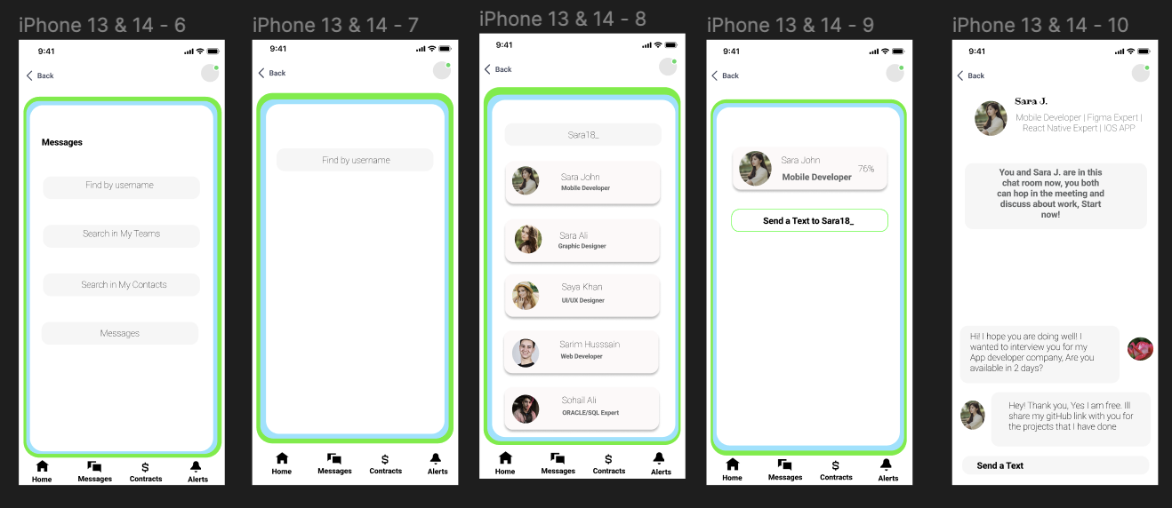

The Figma and UI design sequence shows the user experience from the homepage to text discussions in the global networking app. Professional communication and teamwork depend on messaging, therefore this flow emphasizes it. Users are sent to the first screen after clicking "Send a Text" on the homepage. The interface is sleek and includes "Find by username," "Search in My Teams," "Search in My Contacts," and a direct access to "Messages." This design helps consumers find connections and start discussions fast.

Second screen shows "Find by username" feature. Enter the username of the person you want to connect with. The basic design emphasizes the search bar to simplify user discovery. The third screen displays username search results. Each possible match has a profile photo, name, and work title. This structure lets users rapidly find the right contact. Visual consistency and layout simplicity make navigation and use easy. A selected contact's professional function (e.g., "Mobile Developer") is displayed on the fourth screen. A conspicuous "Send a Text to [Username]" button makes it easy to start a discussion. A clear call-to-action improves user experience by giving an instant next step. Final screen shows active discussion interface. It reinforces the professional setting of the engagement with the contact's profile at the top. The discussion section displays user communication with message boxes. The UI provides a concentrated chat environment with bottom-mounted message sending options.

The design makes communicating easy and efficient, letting people connect, interact, and cooperate. Search options and a simple message interface help the app improve professional encounters, which are vital for worldwide networking and cooperation. This sequence of Figma and UI displays emphasizes the app's focus on easy navigation, straightforward communication, and fast professional networking. The design makes it easy for users to identify connections, start conversations, and have relevant professional interactions, improving their networking experience.

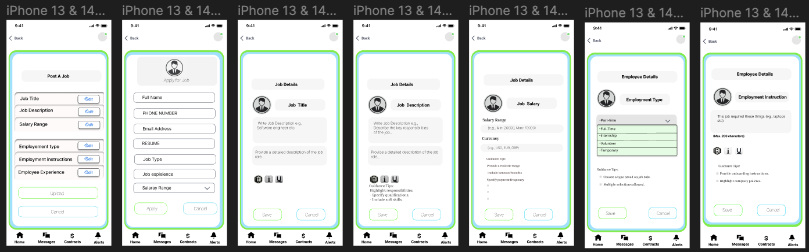

The Figma and UI design discusses publishing and applying for global networking app jobs. Job seekers and companies benefit from this sequence's simple navigation and management.The webpage's "Post a Job" button opens the job posting interface. Employers can organize job data on the first screen. Key fields include "Job Title," "Job Description," "Salary Range," "Employment Type," "Employment Instructions," & "Employee Experience." Employers may edit each field using "Edit". The interface is simple, so companies may post jobs quickly. Employers can upload appropriate papers or photographs using the "Upload" button at the bottom, or terminate the process using the "Cancel" button.

Job specifics are detailed in future screens. Employers might list duties and competencies in job descriptions. They can also define salary range and currency to set compensation expectations. Job postings may be exact and helpful by selecting part-time, full-time, internship, volunteer, and temporary employment kinds. Employers might also specify employment criteria and norms. The homepage "Apply on Job" button opens the job application screen. The second screen asks job searchers to fill out a form. Required fields: "Full Name," "Phone Number," "Email Address," "Resume," "Job Type," "Job Experience," and "Salary Range." To streamline the application process, this form requires all relevant information from job searchers. Users can submit applications using the bottom "Apply" button or cancel the process using the "Cancel" button.

The last screens reveal the job title, description, and pay, helping candidates understand the role. Employment kinds and instructions provide candidates context and guarantee they have all they need. Figma and UI job posting and application flow design emphasize clarity, usability, and completeness. Editable fields and structured forms ease job advertising for firms. Job seekers may apply easily with clear entry fields and accurate job info. Saving and cancelling buttons across the UI simplify action management and improve user experience. The worldwide networking software helps businesses locate competent candidates and job seekers find relevant opportunities.

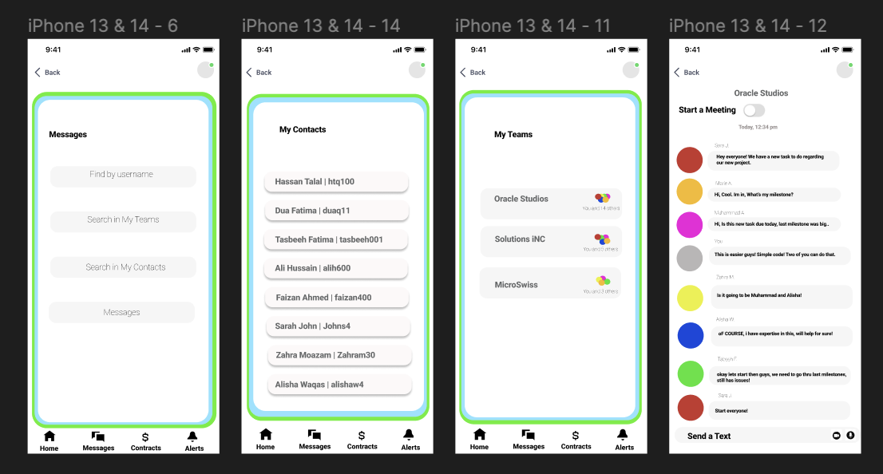

The Figma and UI design shows the worldwide networking app's user path from homepage to messaging. This flow organizes messages through search, contact lists, and team groups to let users collaborate. Users enter the messaging interface by clicking "Messages" on the site. This screen includes "Find by username," "Search in My Teams," and "Search in My Contacts," as well as a link to see all messages. This structure allows users to easily find and start conversations, assuring speedy access to the right channel. Screen 2 shows "My Contacts" interface. It lists the user's connections. Each contact has a name and username, making it easy for users to choose who to contact. The simple style promotes navigation and easy access to contact information.

Third screen shows "My Teams" interface. This section shows the user's teams and their membership numbers. Group workers use this interface to maintain and access team communications. The visual arrangement of teams lets users find and interact with specific groups, improving cooperation. The last screen shows the active team chat interface. It shows team conversations, like "Oracle Studios." Each message bubble is color-coded and tagged with the sender's name for readability and conversation tracking. The top "Start a Meeting" option lets users swiftly switch from text chat to a video meeting for real-time collaboration. The bottom text input box encourages constant involvement, making message sending efficient. The communications section's Figma and UI design emphasizes usability, navigation, and organization. The basic search options offer many methods to locate contacts and messages, while the contacts and teams interfaces arrange relationships rationally. Clear and easy active chat interfaces enable text discussions and brief video sessions. Users may handle business communications and boost app collaboration and networking with this entire technique. By facilitating fast, organized, and effective chats, the worldwide networking software meets users' communication needs.

# References

Schiller, D. (1999). *Digital capitalism: Networking the global market system*. MIT press.

Ronchi, A. M. (2009). *eCulture: cultural content in the digital age*. Springer Science & Business Media.

Juska, J. M. (2021). *Integrated marketing communication: advertising and promotion in a digital world*. Routledge.

Nardi, B. A., Whittaker, S., & Bradner, E. (2000, December). Interaction and outeraction: Instant messaging in action. In *Proceedings of the 2000 ACM conference on Computer supported cooperative work* (pp. 79-88).

Sampson, R. J. (1988). Local friendship ties and community attachment in mass society: A multilevel systemic model. *American sociological review*, 766-779.

Bughin, J., Catlin, T., Hirt, M., & Willmott, P. (2018). Why digital strategies fail. *McKinsey Quarterly*, *1*(1), 14-25.